Assignment 2
Problem 1
- This problem will familiarize you with estimating some basic image quality parameters like signal-to-noise and contrast-to-noise ratio
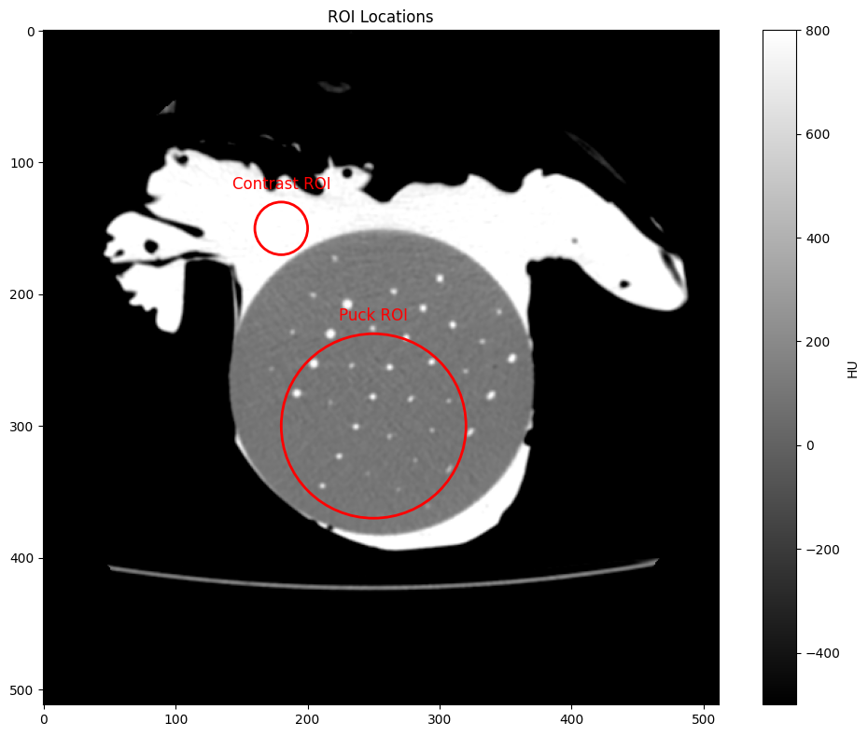
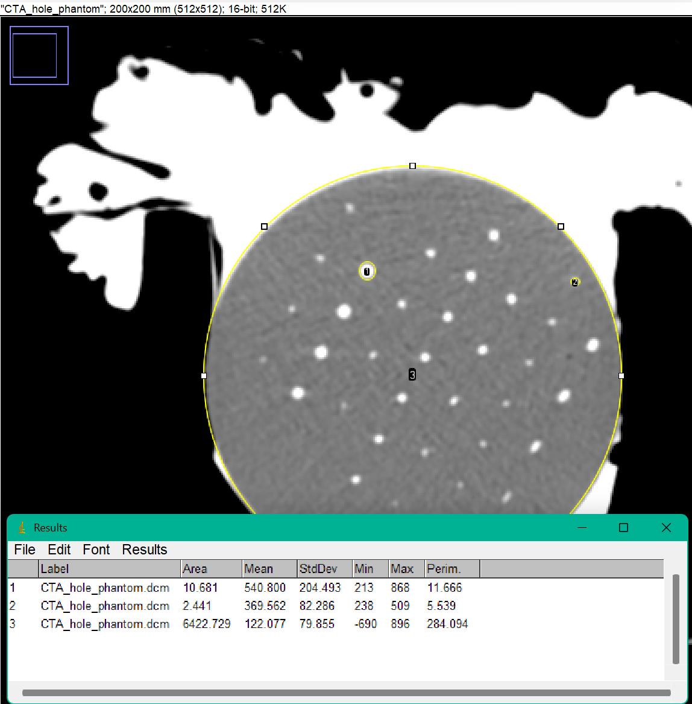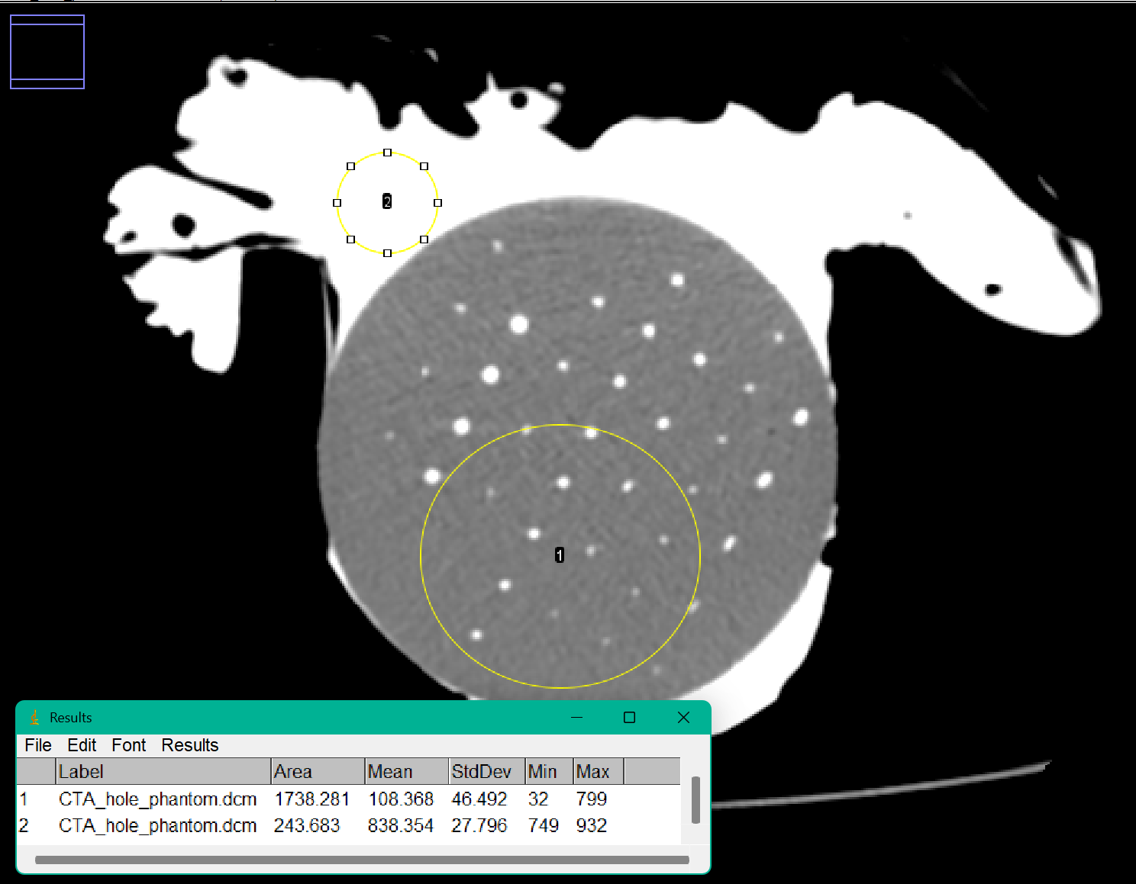
  - (4 pts) What is the average HU value of the bright iodinated contrast?
    - Python: ~838.8 HU and ImageJ: 838.354HU
  - (4 pts) What is the average HU value of the 3D printed phantom disk?
    - Python: ~111.8 HU and ImageJ: 122.077HU
  - (10 pts) Report SNR and CNR for the 3 mm and 1.4 mm holes. For both SNR and CNR, normalize using the standard deviation of the phantom background.
    - SNR: 3mm = 6.77 and 1.4mm = 4.63
    - CNR: 3mm = 5.24 and 1.4mm = 3.10
  - (4 pts) What do you observe about the signal amplitude of the holes in the blue rectangle as the diameter decreases from 1.4 mm to 0.8 mm?
Hint: measure the max value at the center (or at least as close as you can get to the center) of each hole.
    - The signal amplitude of the holes in the blue rectangle is decreasing significantly as the radius decreases from 1.4 mm to 0.8mm. The max HU value at the 1.44 mm hole hits a peak of 509 HU but drops by 50% at the 0.8mm hole which has a max of 257 HU.
This behavior is potentially due to the hole's size getting smaller than a pixel, so when it's capturing the contrast at the middle of it, it's averaging both the hole and the phantom material surrounding it.
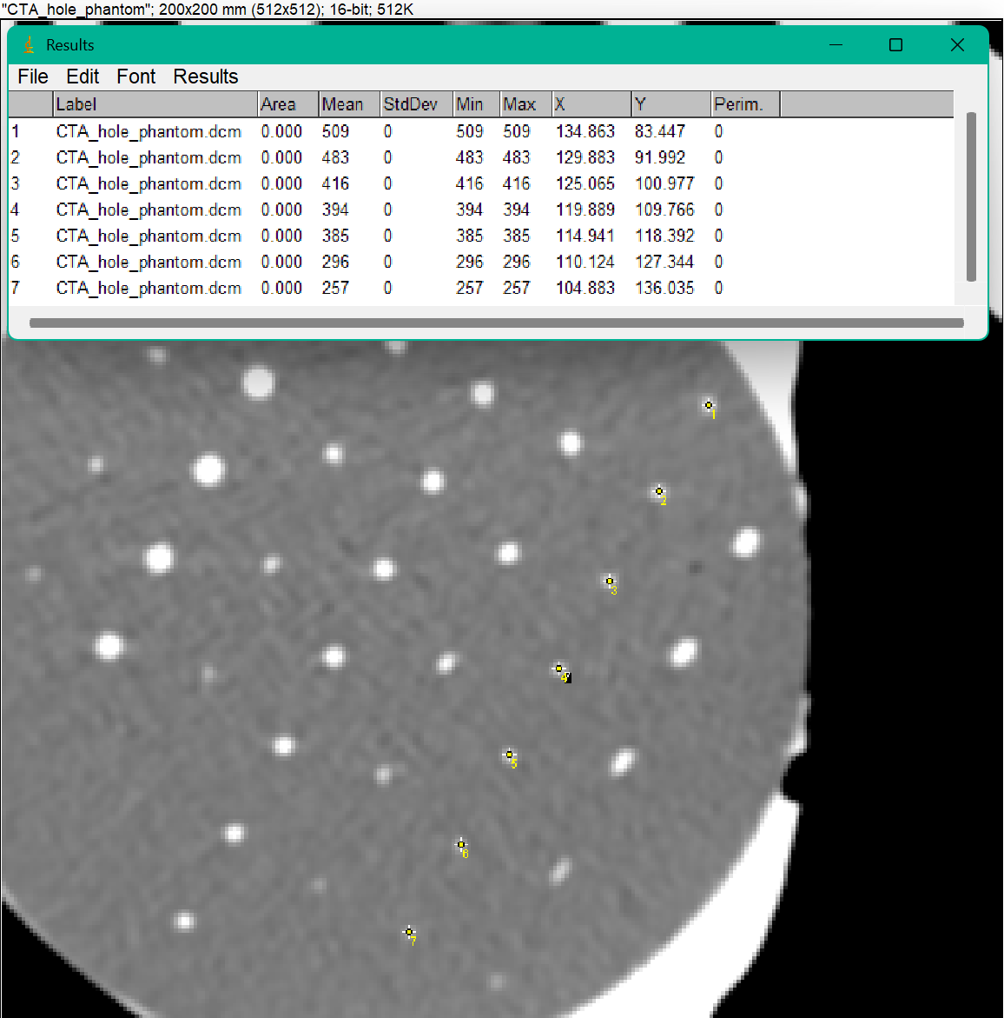
  - (8 pts) Can you estimate the smallest diameter hole that you can detect in this image with 95% statistical confidence?
Hint: Use linear regression to fit maximum (peak) signal
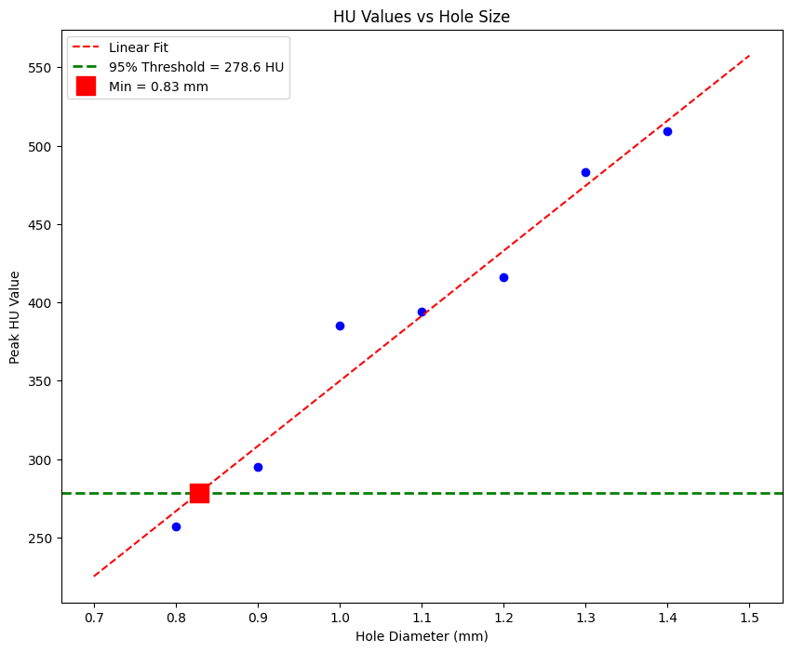
    - Min diameter = 0.83mm
Problem 2
- (20 pts) We will look at the same phantom as in Problem 1. The only difference is that this image was acquired with the phantom placed in a fat-equivalent extension ring to more closely simulate imaging a human subject with fat and muscle surrounding the internal organs of interest.
  - (12 pts) Using quantitative metric(s), can you describe how this image is different from the one in problem 1?
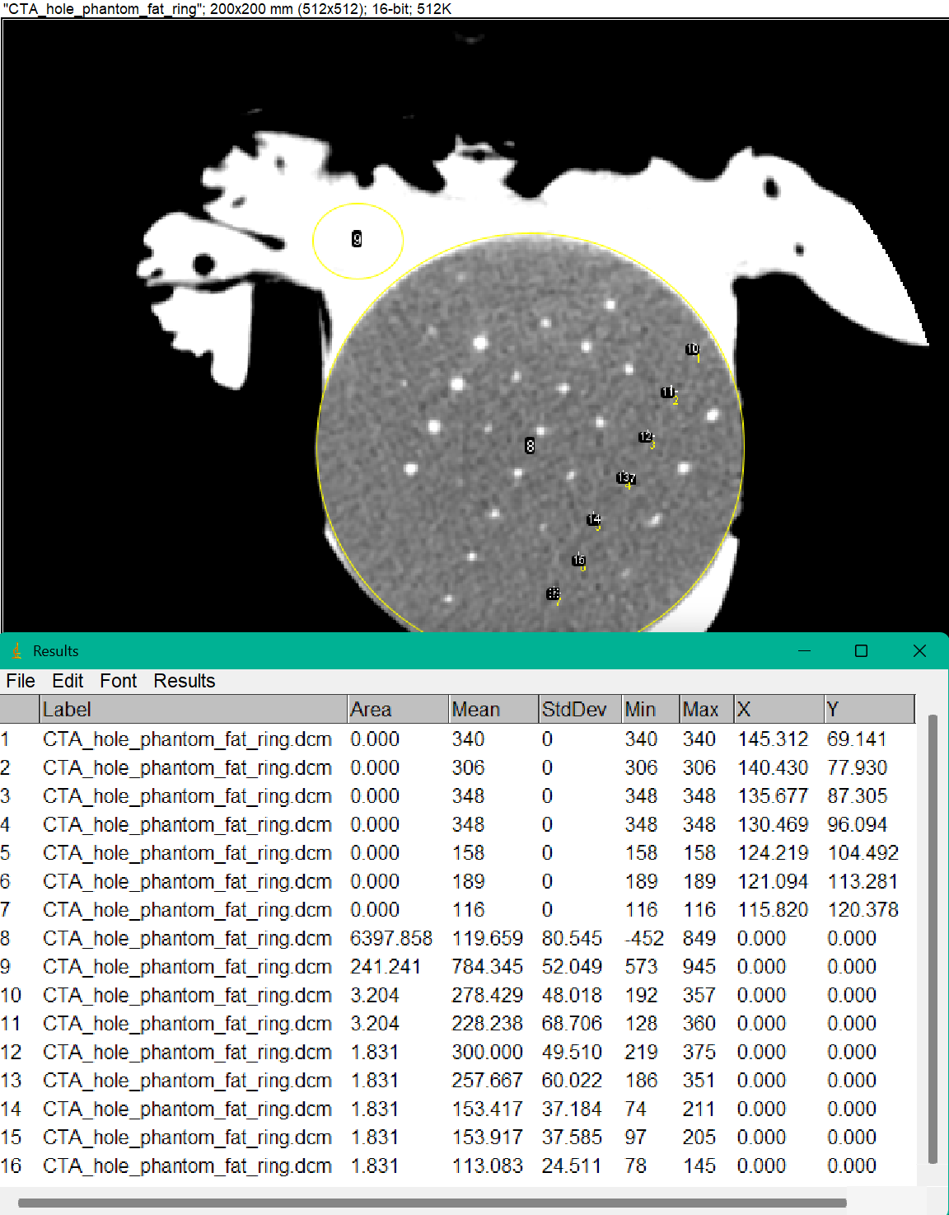
    - In comparing the phantom in the fat ring to the original, I measured the same metrics that were done in problem 1. This includes analyzing the mean HU value for different regions, image noise, and the SNR/CNR for the 1.4mm hole.
The average HU for this phantom is 119.659 HU and the standard deviation is 80.545 HU. Compared to the original phantom which had a mean of 122.077 HU and a standard deviation of 79.855 HU, the mean HU decreased slightly while the noise stayed about the same.
The peak hole signals are significantly different in mean intensity compared to the original, and the pattern of HU decreasing as the holes get smaller is less clear. This could be due to the difficulty identifying the holes since they blend more into the background since the fat ring scatters x-rays differently than air, which could add noise and reduce the image’s quality.
This is definitely noticeable in the SNR/CNR calculations where the SNR equals 3.46 and CNR equals 1.97, both significantly smaller than the original (SNR = 6.77, CNR = 3.10). The lower SNR and CNR values indicate that the holes are harder to distinguish from the background noise, making them more difficult to detect.
  - (8 pts) Similar to Problem 1e, can you estimate the smallest diameter hole that can be detected with 95% statistical confidence?
Hint: You may not need to even perform a linear regression because some of the provided holes themselves may be too small to be detected with confidence.
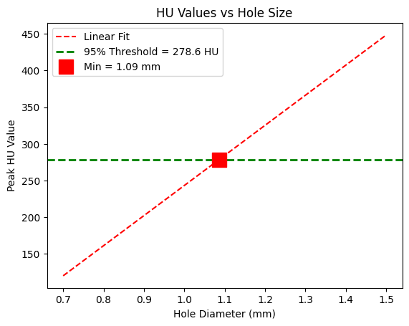
    - Min. diameter of 1.09mm which is significantly larger than problem 1. Overall, the fat ring degrades the image’s quality, making smaller holes much harder to detect.
Problem 3
- (15 pts) In this problem, you will estimate the MTF of the imaging system using a 3D printed phantom with varying spatial frequencies of holes drilled into it.
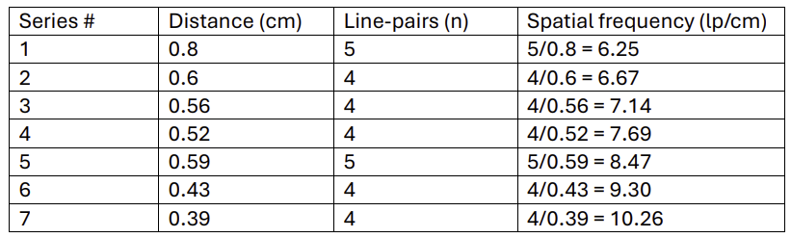
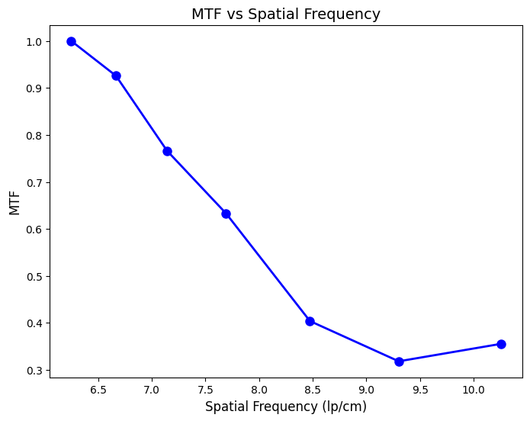
  - The MTF curve shows that the system's ability to preserve contrast decreases as spatial frequency increases. In the graph, the MTF is normalized to 1.0 at the lowest spatial frequency 6.25 lp/cm, decreases to about 0.32 at 9.25 lp/cm. This makes sense because as the dots in the lines get closer together the system has a harder time distinguishing between the holes and the background material, causing the contrast to muddle. There is a slight uptick at the highest frequency (10.26 lp/cm) which could be due to noise in the measurements or just difficulty getting accurate readings when the features are so closely spaced.

Problem 4
- (50 pts) In this problem, you will estimate the PSF and MTF of a small titanium bead imaged in a clinical CT scanner.
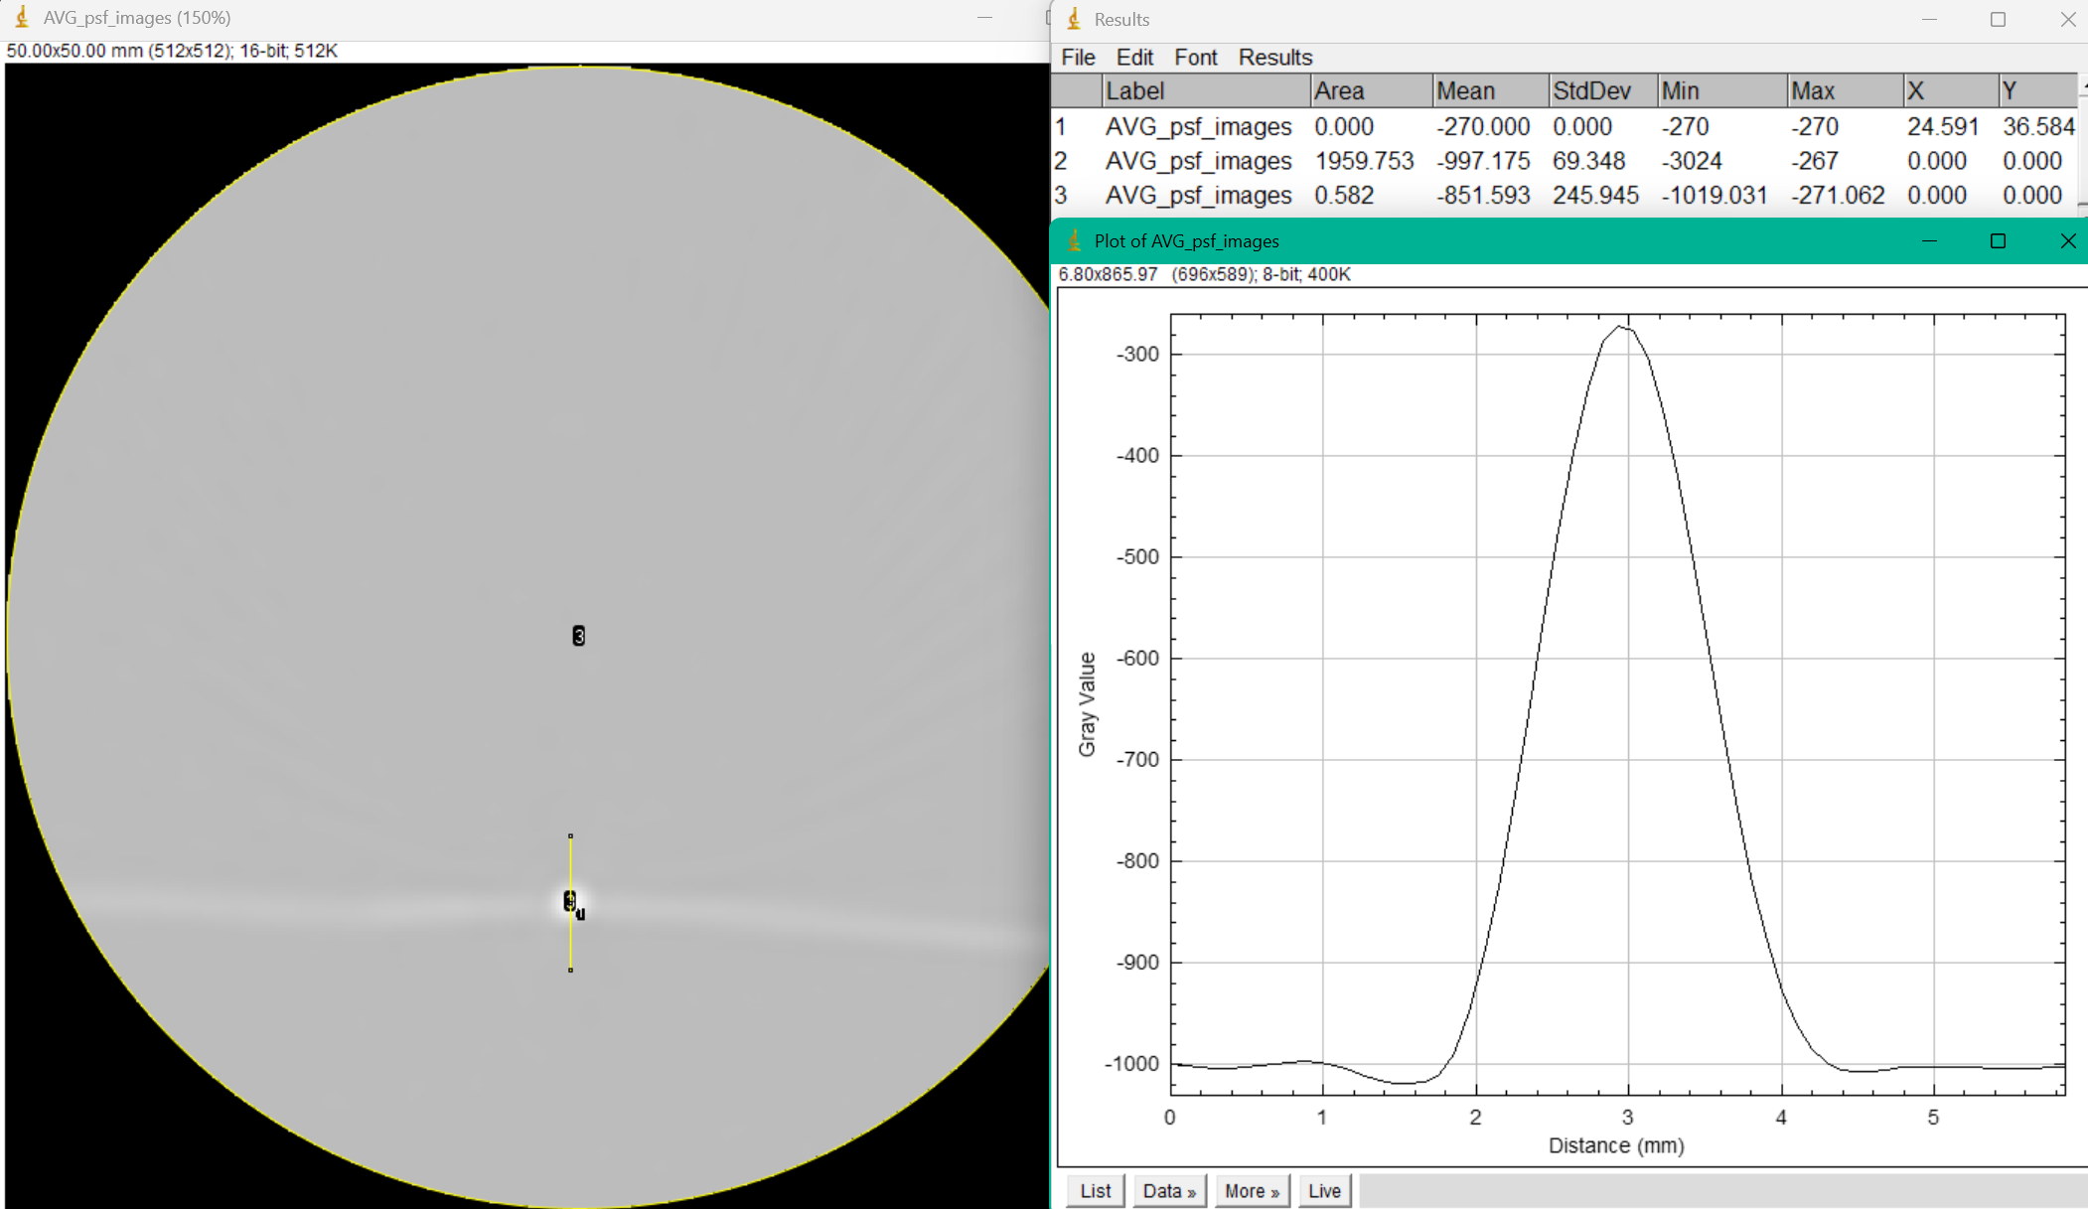
  - (3 pts) Plot the normalized MTF (to enhance visualization, you can limit the x-axis to a frequency of 1.4 mm-1).
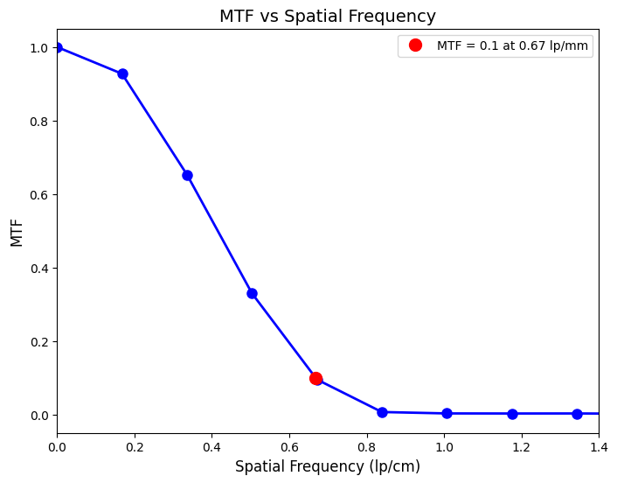
  - (2 pts) Report the spatial frequency corresponding to an MTF value of 0.1.
    - Spatial frequency of 0.67 lp/cm at a value of 0.1 MTF.
    - This means features that have higher spatial frequences than 0.67 lp/cm will have low contrast and will become difficult to detect, following the pattern in problem 3.
  - (3 pts) Plot the shifted line profile (background removed).
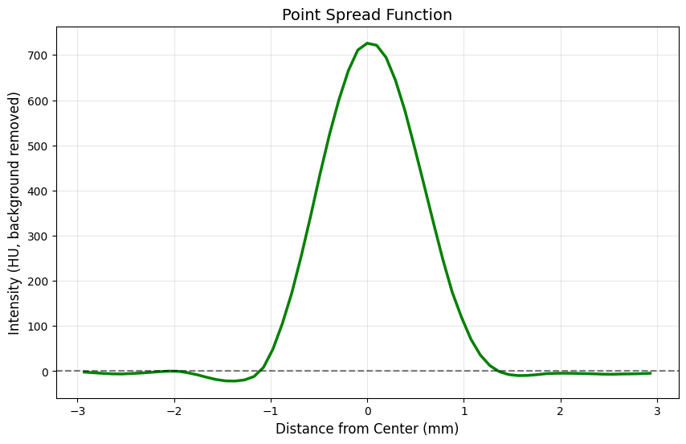
  - (3 pts) Report the full-width-at-half-max value.
    - The full-width-at-half-max value equals 1.1719 mm.
    - This means the system spreads the bead’s signal over 1.17 mm in space. Overall, it reflects the amount of blurring that could be happening to the system.
  - (3 pts) Report the average value of your shifted line profile (background removed) and the DC component of the Fourier transform.
    - Average value of the shifted line profile equals 145.582 HU.
    - DC component of the Fourier transform is 145.582 HU
    - Because the Fourier transform was normalized to the length of the signal, that means F[0]/N equals the mean of the signal so the DC component should equal the average value of the shifted line.

Appendix A: Python Code and Notes
import pydicom
import numpy as np
import matplotlib.pyplot as plt
from matplotlib.patches import Circle
from scipy.stats import linregress
from scipy import stats
import pandas as pd

# File path to the DIOCOM
file_path = 'CTA_hole_phantom.dcm'

# Read the DICOM file
CTA_dcm = pydicom.dcmread(file_path)

# Pixel Data
CTA_dcm.pixel_array

# -----------------------------------------
# Problem 1: Part A and B
# -----------------------------------------
# Convert to HU
CTA_HU = CTA_dcm.pixel_array * CTA_dcm.RescaleSlope + CTA_dcm.RescaleIntercept
print(f"Max HU: {CTA_HU.max():.1f}, Min HU: {CTA_HU.min():.1f}")

# Sample different regions to see actual HU values
# Choose random points in the image to sample HU values
print(f"Black region (background): {CTA_HU[100, 300]:.1f} HU")
print(f"Center of the image (phantom): {CTA_HU[250, 250]:.1f} HU")
print(f"White Region (contrast): {CTA_HU[150, 200]:.1f} HU")

# Display the image
# Adjust vmin (everything that should appear black) and vmax (everything that should appear white)
# Contrast HU = 828.0 so vmax<=828.0
# vmin was adjusted to -500
plt.imshow(CTA_HU, cmap='gray',
vmin=-500, vmax=800)
plt.colorbar(label='HU')
plt.title('CTA Hole Phantom')
plt.xlabel('Pixel row')
plt.ylabel('Pixel column')
plt.show()

# Setting up ROIs to calculate average HU values in regions
rows, cols = CTA_HU.shape # grid of image (512x512)
Y, X = np.ogrid[:rows, :cols] # Creates coordinate grids for the image

# Puck ROI
center1_x, center1_y, radius1 = 250, 300, 70 # Geometric Parameters
dist_from_center1 = np.sqrt((X - center1_x)**2 + (Y - center1_y)**2)
mask1 = dist_from_center1 <= radius1
print(f"Average HU in the puck ROI: {CTA_HU[mask1].mean():.1f} HU")

# Contrast ROI
center2_x, center2_y, radius2 = 180, 150, 20
dist_from_center2 = np.sqrt((X - center2_x)**2 + (Y - center2_y)**2)
mask2 = dist_from_center2 <= radius2
print(f"Average HU in the contrast ROI: {CTA_HU[mask2].mean():.1f} HU")

# Apply masks to image
fig, ax = plt.subplots(figsize=(10, 8))
ax.imshow(CTA_HU, cmap='gray', vmin=-500, vmax=800)

# Draw both circles in red
circle1 = Circle((center1_x, center1_y), radius1,
linewidth=2, edgecolor='red', facecolor='none')
ax.add_patch(circle1)
circle2 = Circle((center2_x, center2_y), radius2,
linewidth=2, edgecolor='red', facecolor='none')
ax.add_patch(circle2)

# Annotate ROI
ax.annotate('Puck ROI', (center1_x, center1_y - radius1 - 10),
color='red', fontsize=12, ha='center')
ax.annotate('Contrast ROI', (center2_x, center2_y - radius2 - 10),
color='red', fontsize=12, ha='center')

ax.set_title('ROI Locations')
plt.colorbar(ax.imshow(CTA_HU, cmap='gray', vmin=-500, vmax=800),
ax=ax, label='HU')
plt.tight_layout()
plt.show()
# Sanity check with ImajeJ... Could have just used ImageJ

# -----------------------------------------
# Problem 1: Part C
# -----------------------------------------
# Find the Coordinates for the holes using ImageJ - MultiPoint
x_3mm, y_3mm = [89.993], [80.875]
x_1mm, y_1mm = [134.790], [83.452]

# Lecture 11: SNR = I_t/sigma_b
# SNR = Intensity of the object / Standard Deviation of the background noise
# CNR = (I_t - I_b) / sigma_b
# CNR = Intensity of the object - Background/ Standard Deviation of the background noise
# Calculate SNR and CNR for the 3mm hole
I_t_3mm = 540.800 # Average HU from ImageJ
I_t_1mm = 369.562 # Average HU from ImageJ
I_b = 122.077 # Average HU from ImageJ
sigma_b = 79.855 # Standard Deviation from ImageJ
print(f"SNR for 3mm hole: {I_t_3mm / sigma_b:.2f}")
print(f"CNR for 3mm hole: {abs(I_t_3mm - I_b) / sigma_b:.2f}")
print(f"SNR for 1.4mm hole: {I_t_1mm / sigma_b:.2f}")
print(f"CNR for 1.4mm hole: {abs(I_t_1mm - I_b) / sigma_b:.2f}")

# -----------------------------------------
# Problem 1: Part D
# -----------------------------------------
# HU values for holes 3mm to 0.8mm
hole_sizes = np.array([1.4, 1.3, 1.2, 1.1, 1.0, 0.9, 0.8]) # Given
hole_HU = np.array([509, 483, 416, 394, 385, 295, 257]) # MAX from ImageJ

# Plot HU values vs hole size
plt.figure(figsize=(10, 8))
plt.scatter(hole_sizes, hole_HU, color='blue')

# Add regression line
slope, intercept, r_value, p_value, std_err = stats.linregress(hole_sizes, hole_HU)
x_fit = np.linspace(0.7, 1.5, 100)
y_fit = slope * x_fit + intercept
plt.plot(x_fit, y_fit, 'r--', label='Linear Fit')

# 95% confidence interval: z_score = 1.96
# threshold = phantom background + 1.96*standard deviation of the background
# min_diameter = threshold intersects with linear regression line
threshold = I_b + 1.96 * sigma_b
min_diameter = (threshold - intercept) / slope

# Threshold line and minimum diameter point
plt.axhline(threshold, color='green', linestyle='--', linewidth=2,
label=f'95% Threshold = {threshold:.1f} HU')
plt.plot(min_diameter, threshold, 'rs', markersize=15,
label=f'Min = {min_diameter:.2f} mm')

plt.xlabel('Hole Diameter (mm)')
plt.ylabel('Peak HU Value')
plt.title('HU Values vs Hole Size')
plt.legend()
plt.show()

# -----------------------------------------
# Problem 2: Part A and B
# -----------------------------------------
# Noise Ratios
I_t_1mm_2 = 278.429 # Average HU from ImageJ
I_b_2 = 119.659 # Average HU from ImageJ
sigma_b_2 = 80.545 # Standard Deviation from ImageJ
print(f"SNR for 1.4mm hole with fat ring: {I_t_1mm_2 / sigma_b_2:.2f}")
print(f"CNR for 1.4mm hole with fat ring: {abs(I_t_1mm_2 - I_b_2) / sigma_b_2:.2f}")

# Hole sizes are the same
hole_HU_2 = np.array([357, 360, 372, 351, 225, 185, 140]) # MAX from ImageJ

# Add regression line
slope, intercept, r_value, p_value, std_err = stats.linregress(hole_sizes, hole_HU_2)
x_fit = np.linspace(0.7, 1.5, 100)
y_fit = slope * x_fit + intercept
plt.plot(x_fit, y_fit, 'r--', label='Linear Fit')

# 95% confidence interval: z_score = 1.96
# threshold = phantom background + 1.96*standard deviation of the background
# min_diameter = threshold intersects with linear regression line
threshold = I_b + 1.96 * sigma_b
min_diameter = (threshold - intercept) / slope

# Threshold line and minimum diameter point
plt.axhline(threshold, color='green', linestyle='--', linewidth=2,
label=f'95% Threshold = {threshold:.1f} HU')
plt.plot(min_diameter, threshold, 'rs', markersize=15,
label=f'Min = {min_diameter:.2f} mm')

plt.xlabel('Hole Diameter (mm)')
plt.ylabel('Peak HU Value')
plt.title('HU Values vs Hole Size for phantom in fat ring')
plt.legend()
plt.show()

# -----------------------------------------
# Problem 3
# -----------------------------------------
# MTF (Modulation Transfer Function): ability of an imaging system to reproduce contrast at different spatial frequencies
series_num = np.array([1, 2, 3, 4, 5, 6, 7])
distances = np.array([0.8, 0.6, 0.56, 0.52, 0.59, 0.43, 0.39]) # Given
line_pairs = np.array([5, 4, 4, 4, 5, 4, 4]) # Given
spatial_freq = line_pairs / distances # lp/cm
F_max = np.array([125, 75, -25, -100, -200, -250, -175]) # MAX from ImageJ
F_min = np.array([-1175, -1100, -950, -825, -600, -575, -450]) # MIN from ImageJ

# MTF = (F_max - F_min) / (F_max + F_min)
# F_max = maximum intensity (peak HU) of the hole
# F_min = minimum intensity (background HU) around the hole
MTF = (F_max - F_min) / np.abs(F_max + F_min)

# Normalize MTF values to the MTF at the lowest spatial frequency
# Lowest spatial frequency is Series 1 with 6.25 lp/cm
MTF_normalized = MTF / MTF[0]

# Plot
plt.figure(figsize=(8, 6))
plt.plot(spatial_freq, MTF_normalized, 'bo-', linewidth=2, markersize=8)
plt.xlabel('Spatial Frequency (lp/cm)', fontsize=12)
plt.ylabel('MTF', fontsize=12)
plt.title('MTF vs Spatial Frequency', fontsize=14)
plt.show()

# -----------------------------------------
# Problem 4
# -----------------------------------------
# Step 1 & 2: ImageJ -> File -> Import -> Image Sequence -> Stacks -> Z Project -> Average Intensity
# Step 3: Location of the maximum value in the image (Center of the bead)
[bead_x,bead_y] = [24.591, 36.584] # ImageJ coordinates

# Step 4: Plot the intensity profile along a line through the center of the bead
df_line = pd.read_csv('plot_values.csv') # Line profile data from ImageJ
line_length = df_line['Distance_(mm)'].values # Length along the line profile
line_HU = df_line['Gray_Value'].values # HU values along the line profile
avg_line_HU = -851.593 # Average HU from ImageJ

# Step 5: Average background intensity
bg_HU = -997.175 # Average HU from ImageJ

# Step 6: Subtract the background intensity from the intensity profile
# f_shift = f-mean(background)
bead_shift = line_HU - bg_HU
print(bead_shift)

# Step 7: Compute Fourier transform to estimate MTF
# Discrete Fourier Transform (DFT):
# F = abs(fft(f_shift))
# DC Component: value of the fourier ransform at the origin
# F = abs(fft(f_shit))/N where N = length(f_shift)
N = len(bead_shift)
F = np.fft.fft(bead_shift) / N
MTF_bead = np.abs(F) / np.abs(F[0]) # Normalize by the DC component

# Frequency vector
# u_k = k/N * Sf where u_k is the k-th frequency component
# k = 0, 1,... (N-1)/2
# Sf = sampling frequency
pixel_spacing = line_length[1] - line_length[0]
freq_bead = np.fft.fftfreq(N, pixel_spacing)

# Filter negative frequencies and MTF
positive_mask = freq_bead >= 0
freq_bead = freq_bead[positive_mask]
MTF_bead = MTF_bead[positive_mask]

# -----------------------------------------
# Problem 4 Part A & B
# -----------------------------------------
# Frequency at which MTF drops to 0.1
# MTF Interpolation
target_MTF = 0.1
if target_MTF <= MTF_bead.max() and target_MTF >= MTF_bead.min() and target_MTF <= MTF_bead.max():
target_freq = np.interp(target_MTF, MTF_bead[::-1], freq_bead[::-1])

plt.figure(figsize=(8, 6))
plt.plot(freq_bead, MTF_bead, 'bo-', linewidth=2, markersize=8)
plt.plot(target_freq, target_MTF, 'ro', markersize=10,
label=f'MTF = {target_MTF} at {target_freq:.2f} lp/mm')
plt.xlim(0, 1.4)
plt.xlabel('Spatial Frequency (lp/cm)', fontsize=12)
plt.ylabel('MTF', fontsize=12)
plt.title('MTF vs Spatial Frequency', fontsize=14)
plt.legend()
plt.show()

# -----------------------------------------
# Problem 4 Part C
# -----------------------------------------
# Shifted line profile (background removed) given above
# Distance from the center of the bead
distance_from_center = line_length - line_length[N//2]

plt.figure(figsize=(10, 6))
plt.plot(distance_from_center, bead_shift, 'g-', linewidth=2.5)
plt.axhline(y=0, color='k', linestyle='--', alpha=0.5)
plt.xlabel('Distance from Center (mm)', fontsize=12)
plt.ylabel('Intensity (HU, background removed)', fontsize=12)
plt.title('Point Spread Function', fontsize=14)
plt.grid(True, alpha=0.3)
plt.show()

# -----------------------------------------
# Problem 4 Part D
# -----------------------------------------
# Full-Width-at-Half-Maximum (FWHM): width of the point spread function at half of its maximum value
max_val = np.max(bead_shift)
half_max = max_val / 2.0

# Find where the signal is above half maximum
above_half = bead_shift >= half_max
indices_above = np.where(above_half)[0]

# FWHM in mm
fwhm_mm = (indices_above[-1] - indices_above[0] + 1) * pixel_spacing
print(f"Full-Width-at-Half-Maximum: {fwhm_mm:.4f} mm")

# -----------------------------------------
# Problem 4 Part E
# -----------------------------------------
# Average value of shifted line profile and DC component
mean_shifted = np.mean(bead_shift)
dc_component = np.abs(F[0]) # DC component is the mean of the input signal
print(f"Average value of shifted line profile: {mean_shifted:.6f} HU")
print(f"DC component: {dc_component:.6f}")

Appendix B: Extra Images
Problem 1:
Part c) Getting coordinates and HU values for regions circled 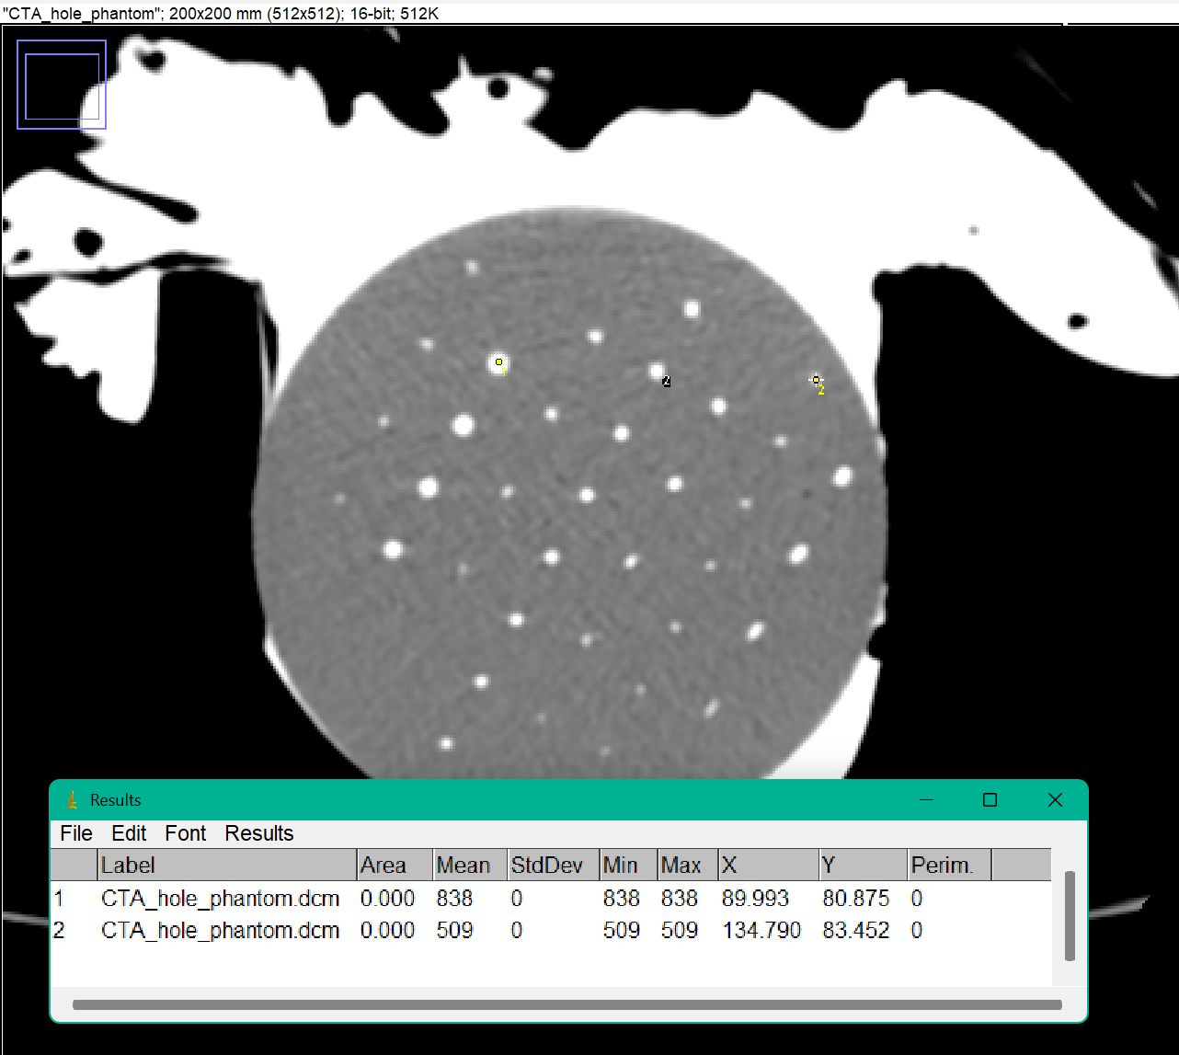
Problem 3: Line profile for each row of holes
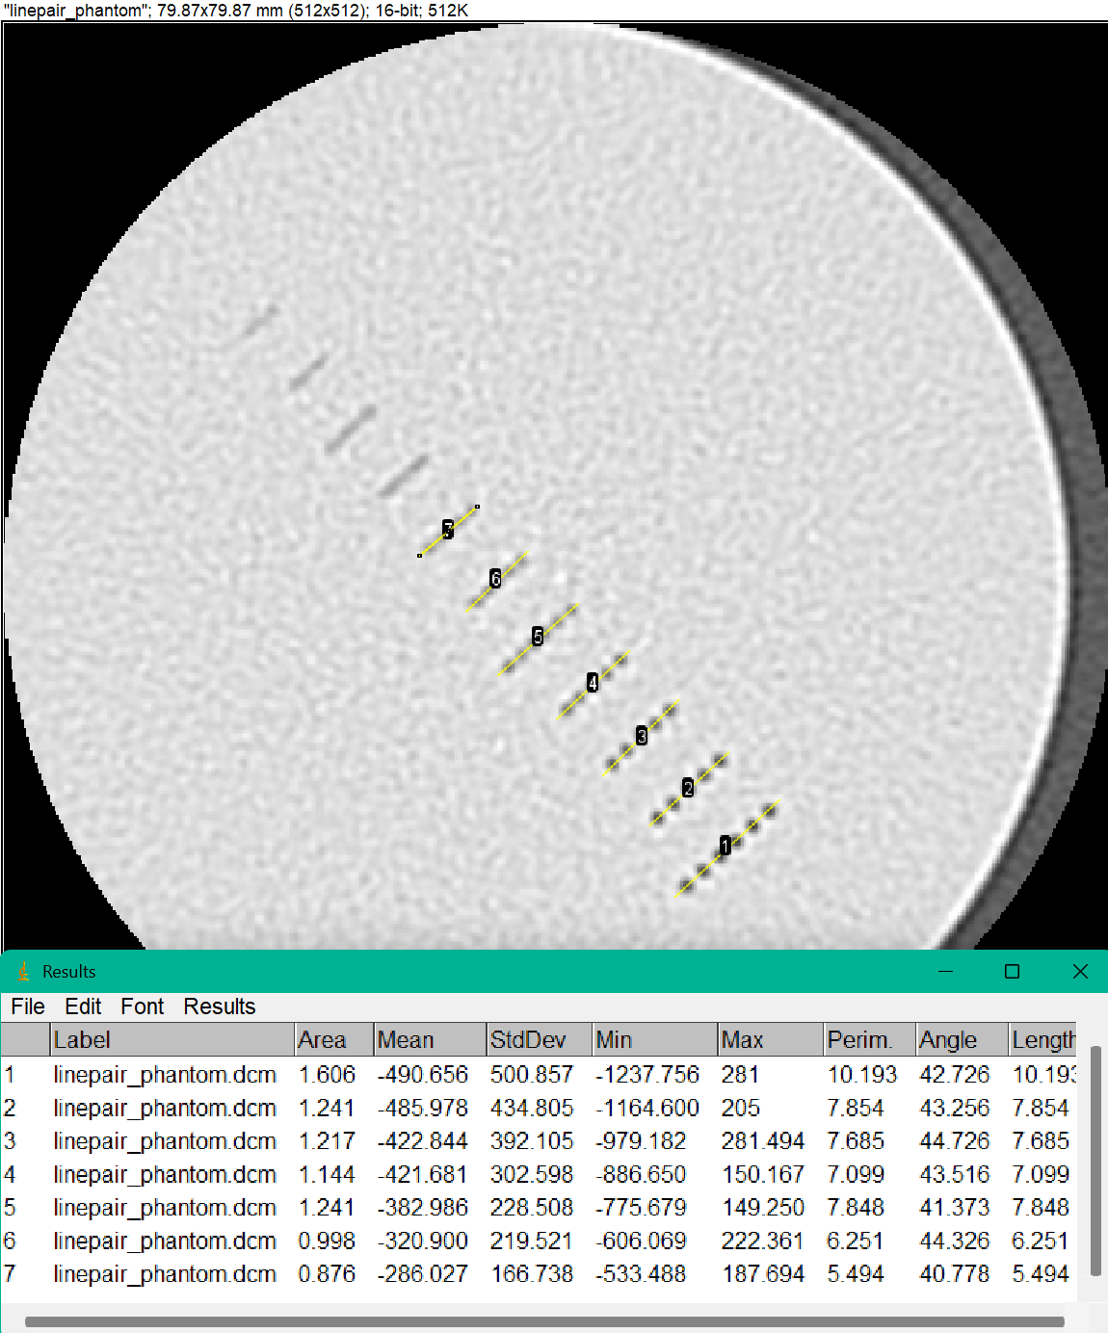

Line 1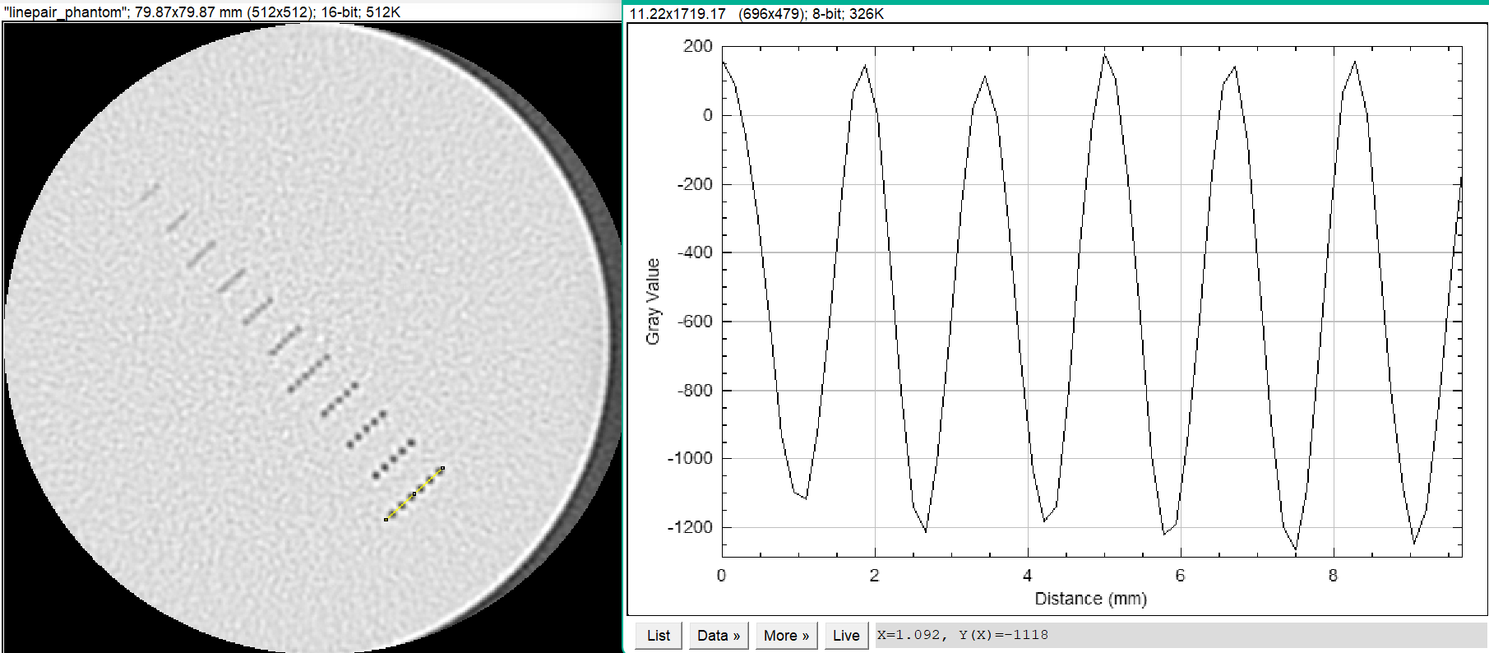
Line 2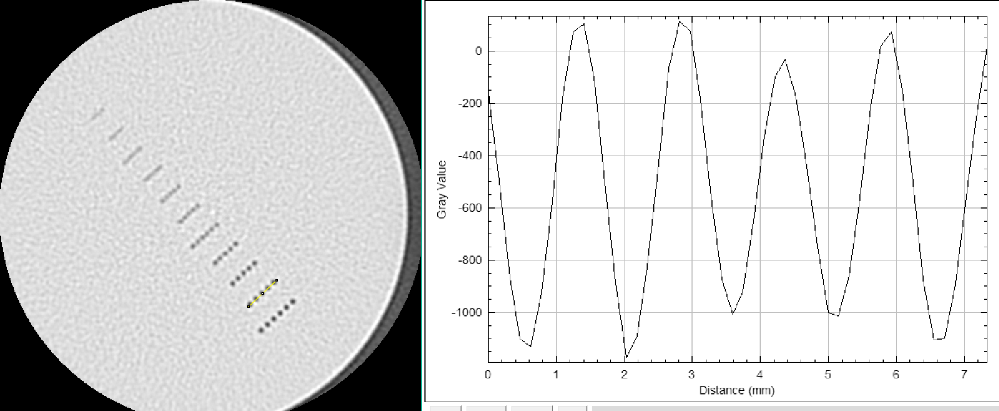
Line 3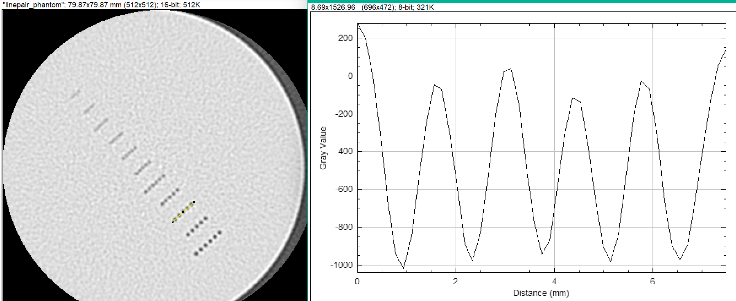
Line 4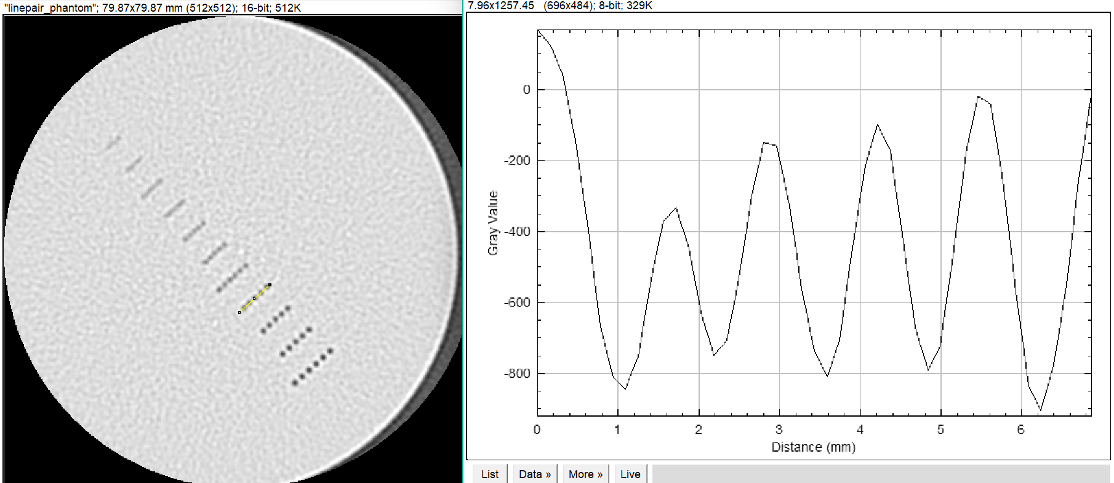
Line 5 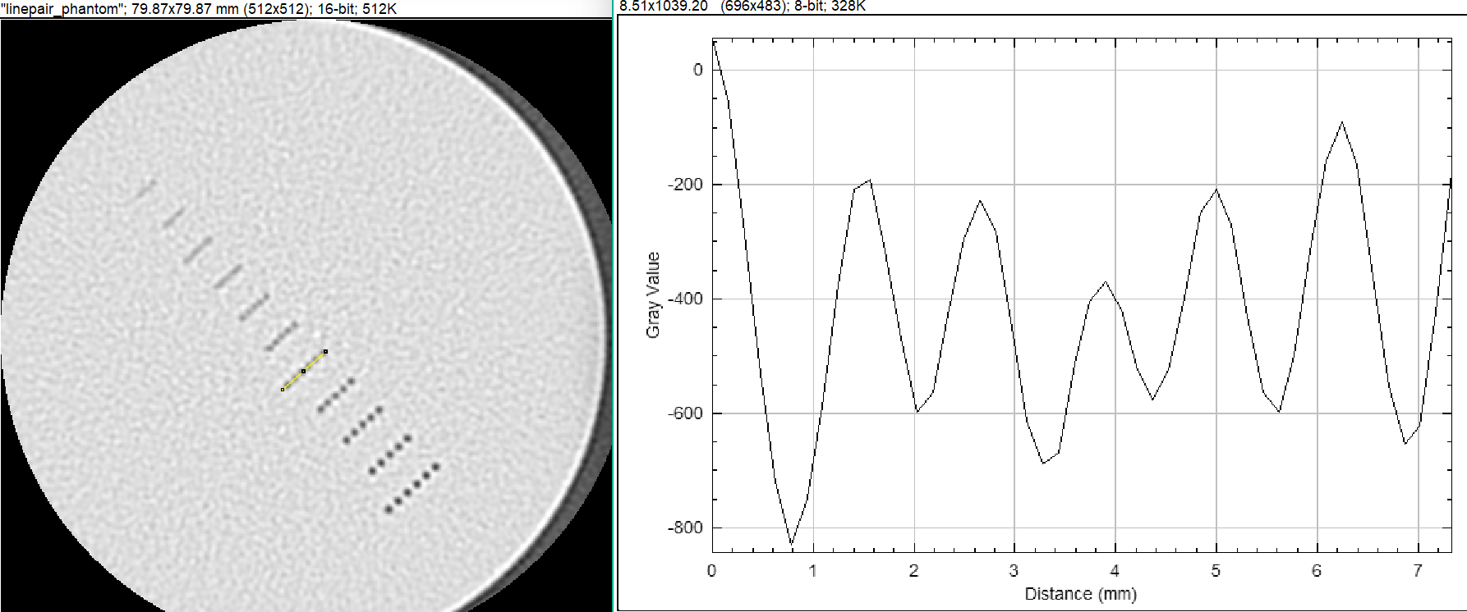
Line 6 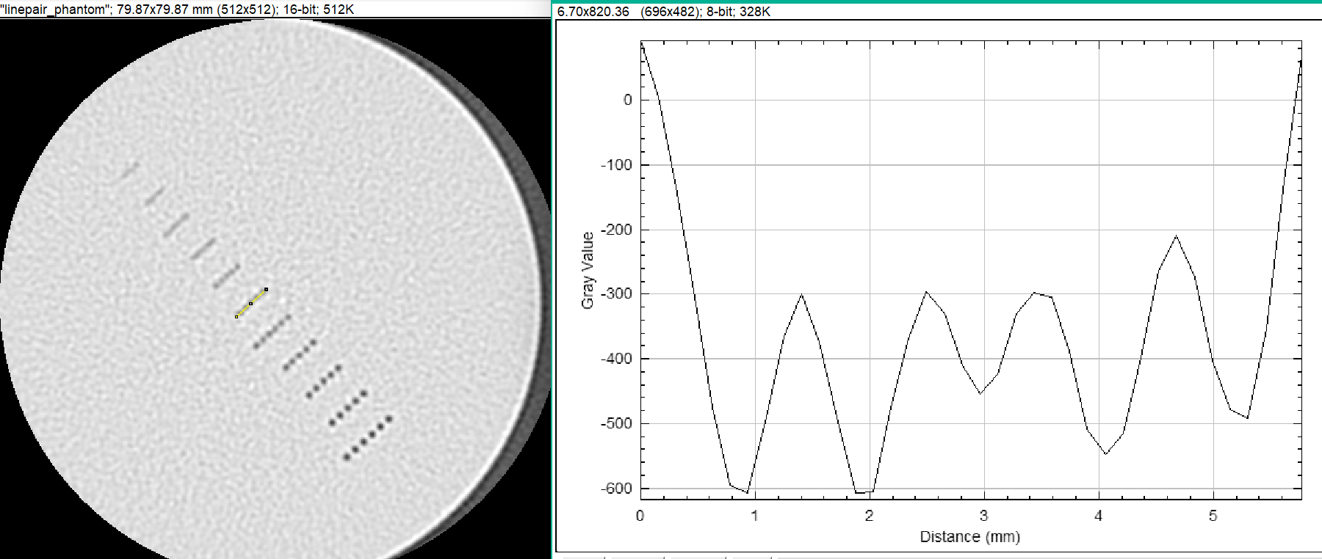
Line 7 